How to use the Search Tool v1.2

Run the executable named IPSearch.exe
You will be presented with the window as shown below:
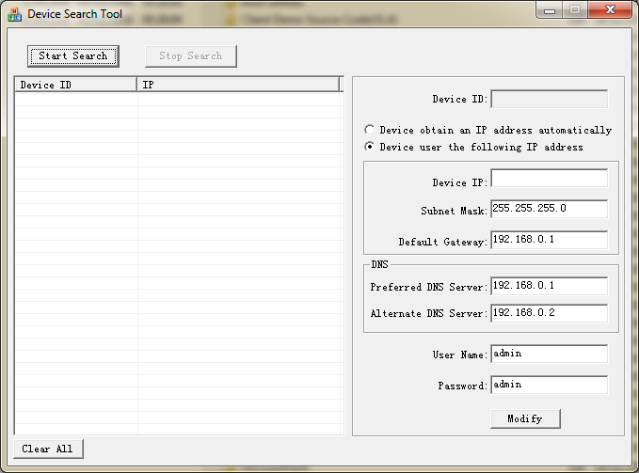

- Just click the Search Start
- Results of the found devices will be reported in the area as shown.
Now change the IP of the devices using the Modify option by selecting the Device ID on the left, and changing the ID Subnet Mask and Gateway.

