TVT API Tool Usage Guide
Introduction
This document makes a brief introduction on how to use the TVT API Tool. API Tool is used for testing two communication interfaces of TVT devices, one is long-pulling communication interface for applying smart functions; another is short-pulling communication interface for acquiring/configuring device settings.

- Testing long-pulling communication interface
- Open the tool, and click buttons as per below sequence. If IP address/username/password needs change, please click Change IP/username/password to change accordingly. If port is to be changed, then click Change Port.
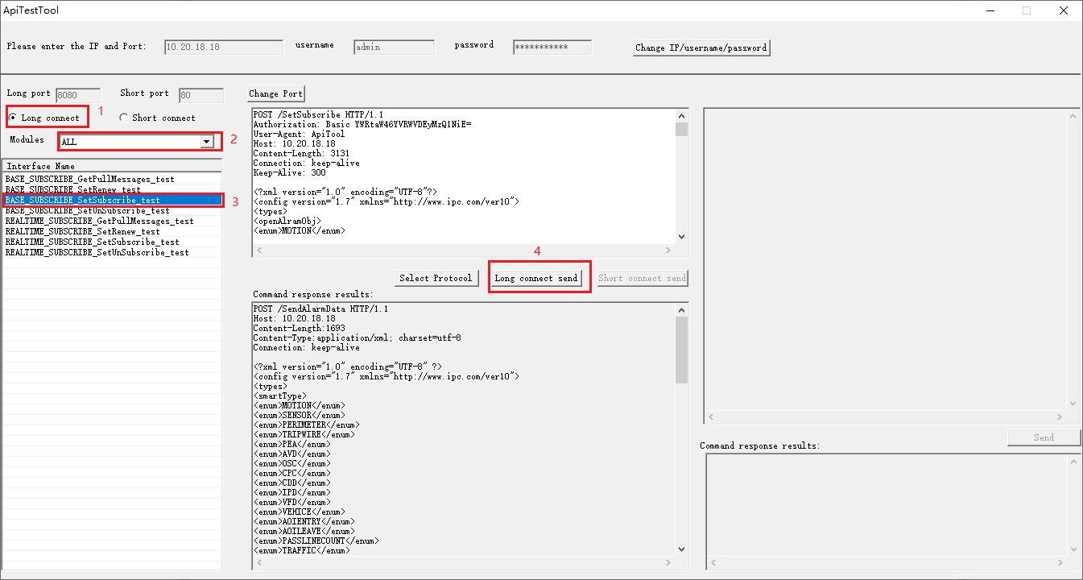

- Testing short-pulling communication interface
- Open the tool, and click buttons as per below sequence. If IP address/username/password needs change, please click Change IP/username/password to change accordingly. If port is to be changed, then click Change Port.
