Update Manual Through U Disk
- only for update from 1.2.X to 1.3.X

Update manual through USB Drive （only for from 1.2.X to 1.3.X）
1、If the version is 1.2.X and below (such as 1.1.0, etc.), the update to 1.3.X version through U disk requires four files:
appfs_special_hi3536;
firmware3536;
N0I_UI1B_133.fls;
ubt3536m.
Put the four files into the USB flash drive. Plug the U Disk to the USB port of the N9000 device, then power off the N9000 device to automatically upgrade.
Figure 1 Update files required

During the upgrade process, the system will be prompted to upgrade (Figure 2). In about 5 minutes, the first step of update will be successful as shown like Figure 3 and Figure 4. 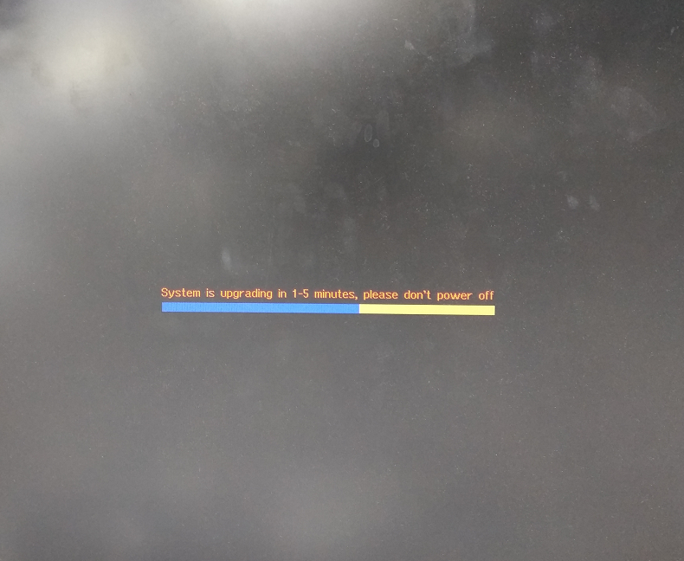
Figure 2
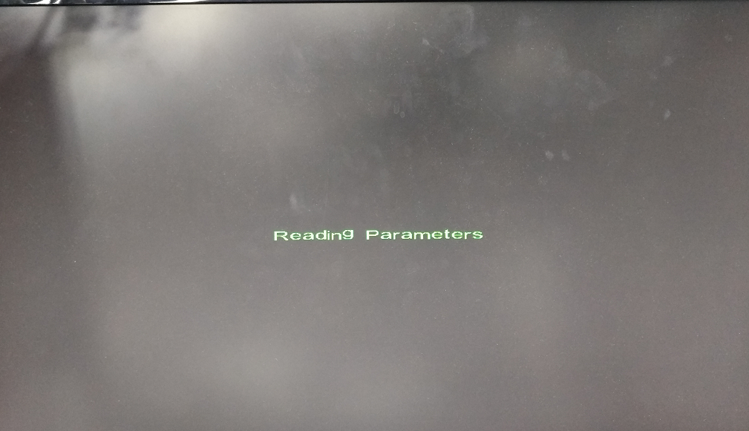
Figure 3
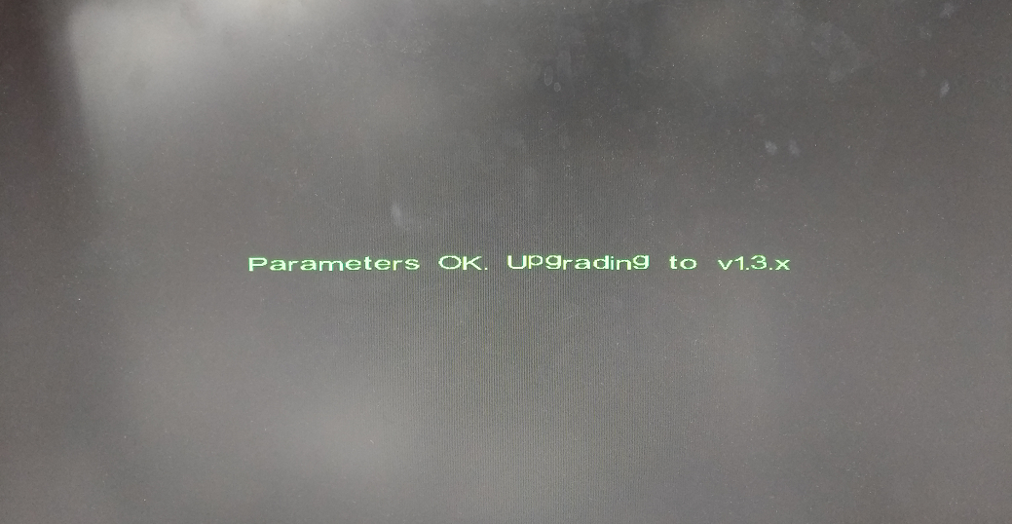
Figure 4
2、The device then automatically upgrades to version 1.3.3 (no need to remove the USB flash drive and reboot), the device screen will display the system prompts for upgrade (Figure 5). The boot logo will appear in about 2 minutes, and it will last for about half a minute. Then there will be an upgrade progressing bar (Figure 6), and it takes about 2 minutes to enter the system. At last, the upgrade is complete.
Figure 5
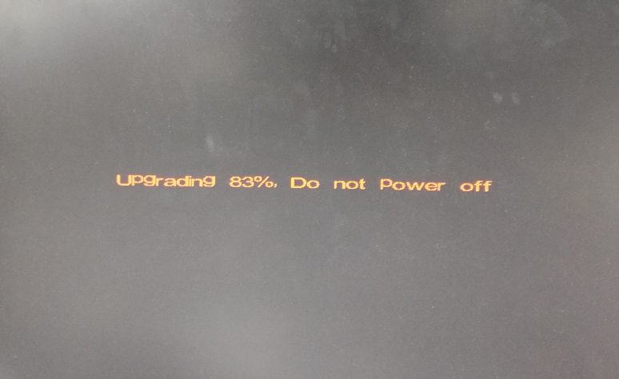
Figure 6 Update processing bar
Note：If the U Disk is connected to the device and the device is powered off for a period of time, the screen is always black. You can try to plug in the video cable. If it is still black, you can unplug the U disk or try another USB port.

