Human Living Body Temperature Detection
And Face recognition Termina

Operation manual

（please read carefully before using the product）

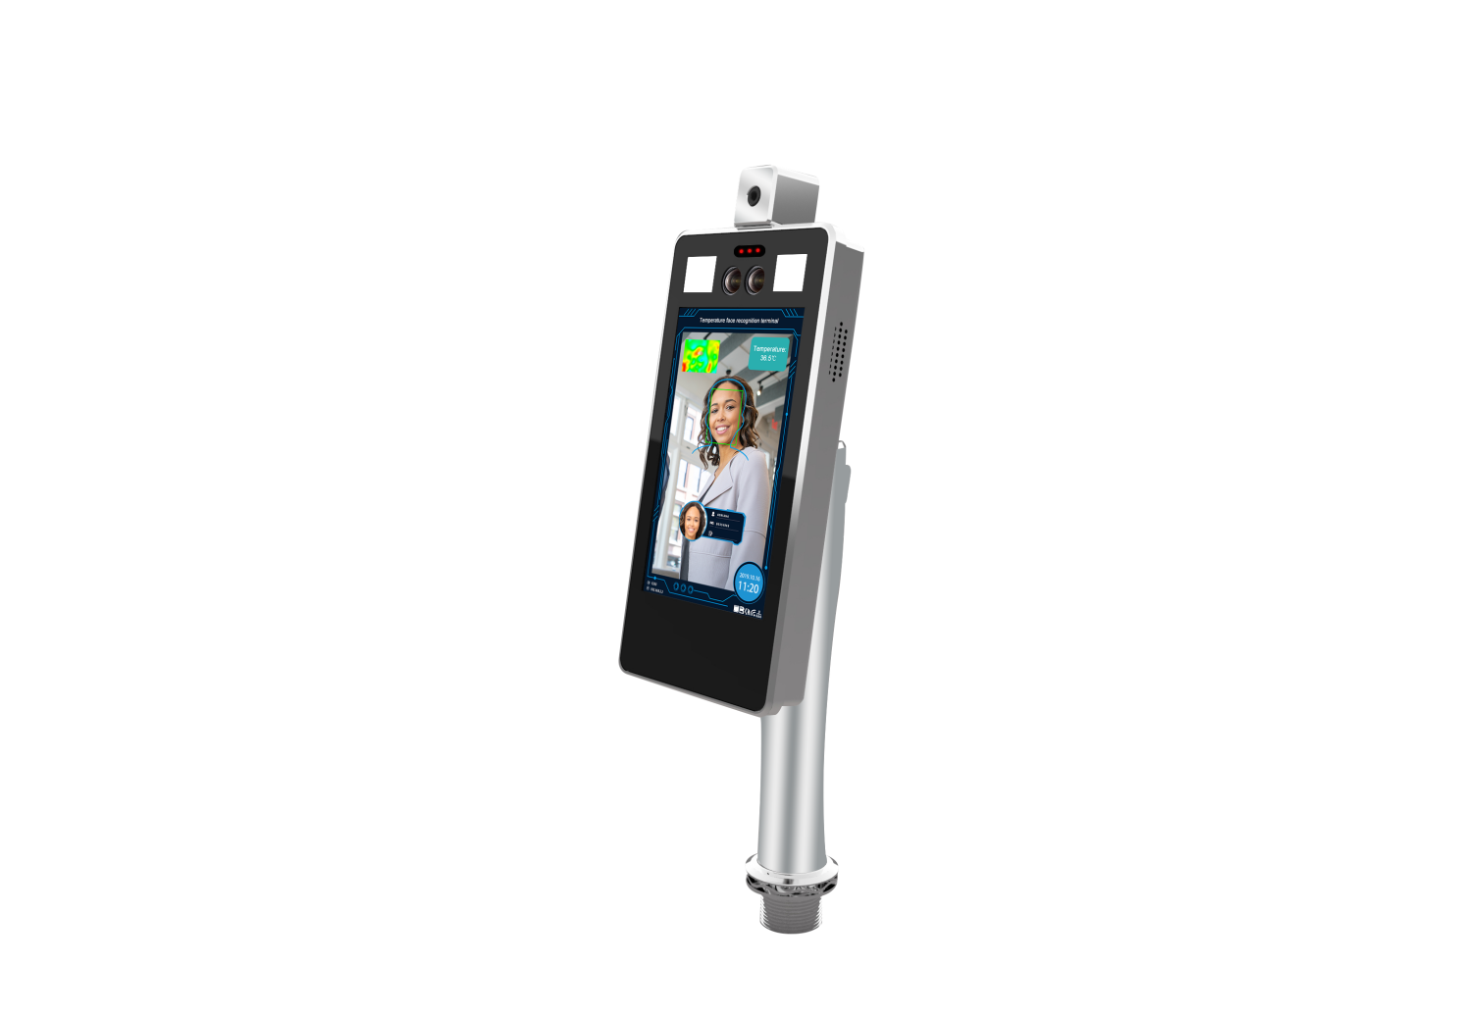

Attention

- This operation manual is for reference only. All appearance and functions of the product are subject to the actual product
- This product can be equipped with optional modules such as 4G, WiFi, ID identification, Weigen IC card reader, etc. Please refer to the actual product
- Do not aim the lens of the device at the object with strong light, as it will affect the capturing effect, or even damage the lens
- Please configure all passwords and other relevant product security settings, and take good care of your user name and password
- Biometrics products cannot be 100% suitable for any security environment or high security use, please use combination authentication
- The firmware of this device will be updated from time to time. For your better experience, please timely maintain and upgrade

Catalogue
1 Product overview 1
1.1 Product introduction 1
1.2 Product features 1
2 Product installation (dimension drawing) 2
2.1 Product installation (dimension drawing) 2
2.2 Vertical installation of channel brake 3
3 Wiring instructions 3
4 Client software 5
4.1 Control ActiveX installation 5
4.2 Login interface 6
4.3 Preview the interface 7
4.4 List management 8
4.4.1 Face picture requirements 8
4.4.2 Single face import 8
4.4.3 Batch face data import 10
4.4.4 Real-time face image import 11
4.4.5 Binary format face library import 12
4.4.6 Exported face library 12
4.5 Peripheral control 13
4.5.1 Basic setup 13
4.5.2 Gate control 13
4.5.3 GPIO control 14
4.5.4 Wiegand configuration 14
4.5.5 Display setup 15
4.5.6 Fill Light 15
4.5.7 Serial port 15
4.6 System configuration 16
4.6.1 Time setup 16
4.6.2 Network setup 17
4.6.3 P2P 17
4.6.4 TF card 17
4.6.5 User management 18
4.7 Parameter Setting 18
4.7.1 Face detection 18
4.7.2 Minimum size of detect target 19
4.7.3 Dispatching management 19
4.7.4 Scene audio 20
4.7.5 OSD setup 21
4.7.6 Video parameter setup 21
4.7.7 Factory calibration 22
4.8 Data upload 22
4.9 System information 23
4.9.1 System information 23
4.9.2 System upgrade 24
4.9.3 System diagnosis 24
4.10 Access records 25

Product overview

Product introduction
The human livding body temperature detection and face recognition terminal is a face comparison terminal product, providing human livding detection, body temperature detection, face capture and comparison and other basic functions. Wifi function, 4G, IC, ID and other corresponding software and hardware modules optional(Standard one do not include these features). It provides a more secure and convenient scheme for people access management. The device can be widely used in building access control, attendance, airport station security, community access control and other scenes.

Product features
- The embedded Linux operating system has an overwhelming advantage over the Andriod system in terms of reliability and stability. Support the output of real-time video stream to other device, one complete face capture, recognition, infrared temperature measurement function.
- Abnormal body temperature alarm: non-contact body surface temperature detection within one second, the temperature measurement distance is 25-40cm, temperature measurement error range ±0.5℃, abnormal body temperature linkage external sound and light alarm.
- Double sensor design, infrared vivo detection algorithm, effectively prevent photos and video fraud.
- Identity card +IC card(alternative) double identification module optinal, can achieve 1:1, 1: N comparison mode.
- The face recognition distance is within 0.5-3 meters, and the face can be recognized and registered in the picture across 260 pixels or more.
- Face detection technology based on improved multi-task cascade convolution neural network is adopted to reduce the requirement of image quality and greatly improve the detection speed of face.
- With the deep learning algorithm, support 10000 face database storage.
- Support local login to query and setup device parameters, view real-time monitoring and face comparison results.
- Support to configurate device parameters in central center, provide security authentication.
- Flexible face data import, support single, batch picture file import and real-time snapshot import.
- Support common person, white list person, blacklist person etc., different face type.
- Support voice broadcast after face recognition
- Support TFTP upload face recogntion data.
- Support to run in offline mode
- Support TF card storage, can store 10W face capture and recognition records.
- Provide 485, I/O input and output, wigan and other peripheral interfaces.
- 4G module is optional to meet the needs of wireless transmission applications.
- Optional sunshade cover, rainproof, anti - light impact image effect.

Product installation（dimension drawing）
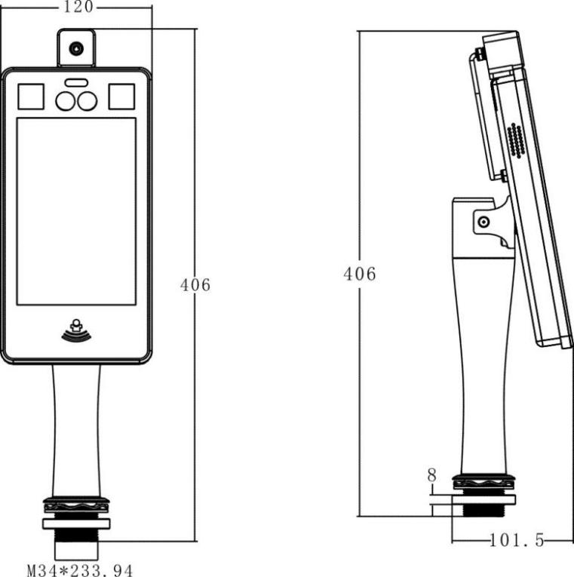

Vertical installation of channel brake
This equipment needs to be installed on the gate machine. Before installation, it is necessary to ensure that the top cover plate of the has been punched with the hole position matching the equipment.

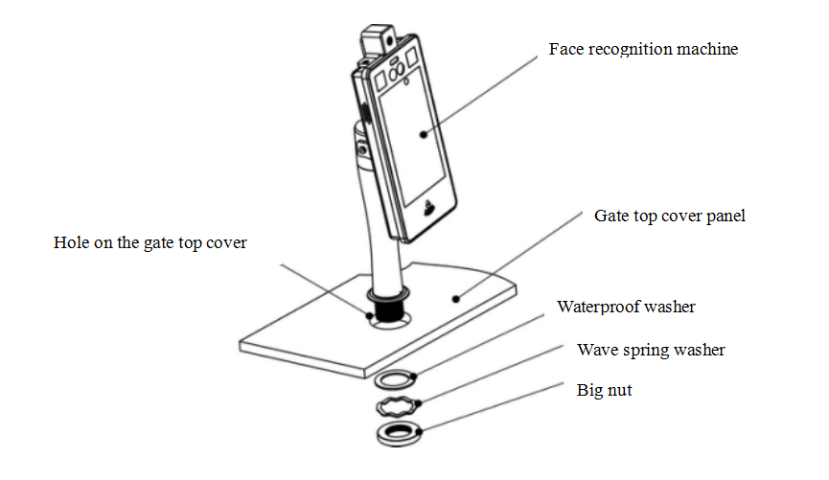
Note: Roof opening size of gate machine is Ø 40 mm (+ / - 2).

Vertical bracket installation method
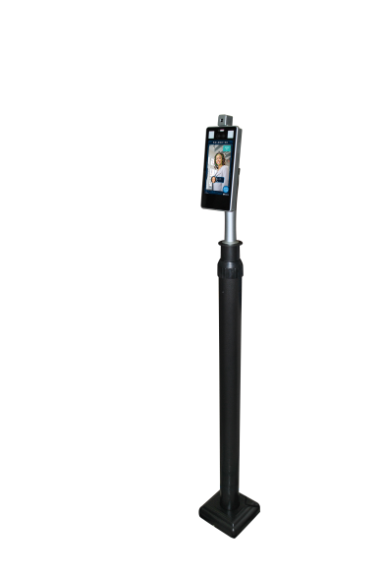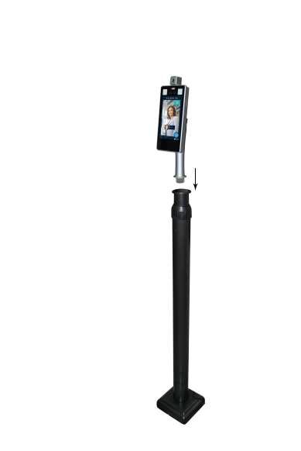
Floor stand rapid deployment
Material：High quality steel
Specification：1-1.5M adjustable
Support bottom screw fixation
Easy to install

Wiring instructions
Wiring diagram is as follows：
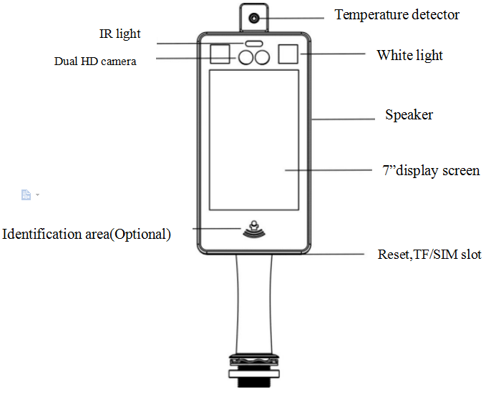

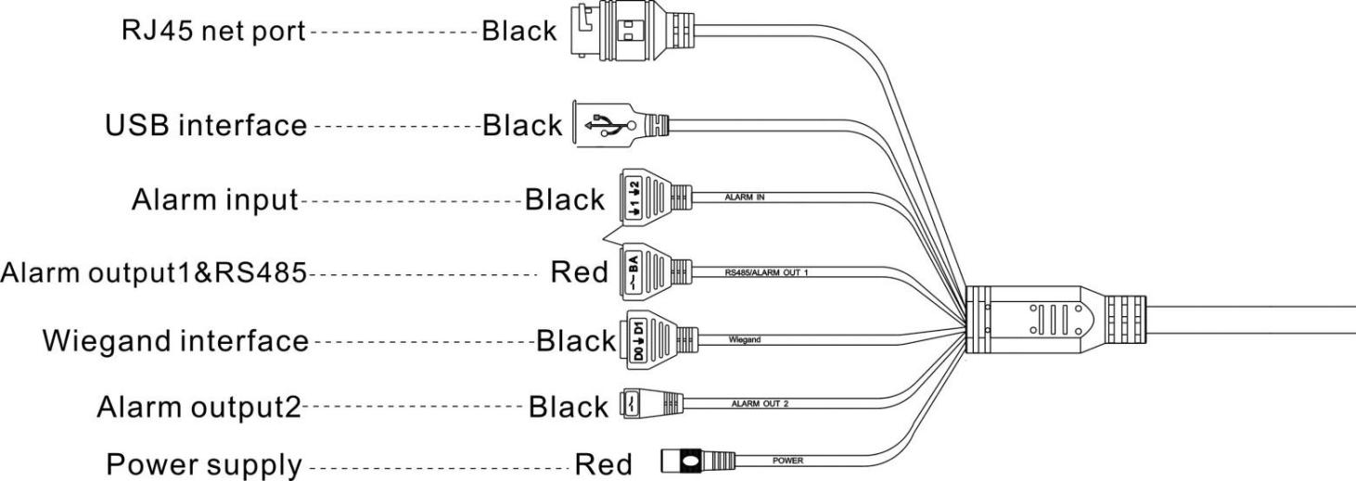

Client software

Control ActiveX installation

Login the device with Internet explorer browser and enter the IP address in the url bar. The device's default IP is 192.168.1.189 (or check the IP in the lower right corner of the device display screen after the power on). After login, download the control and install the control according to the prompts.
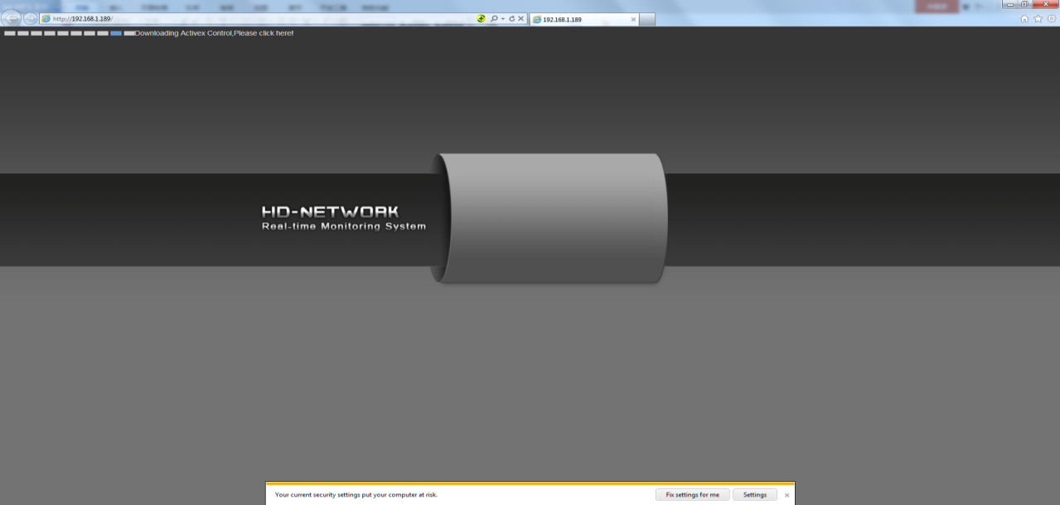
Note: if unable to download, modify Internet explorer browser "tools" menu options, tick off the protected mode.
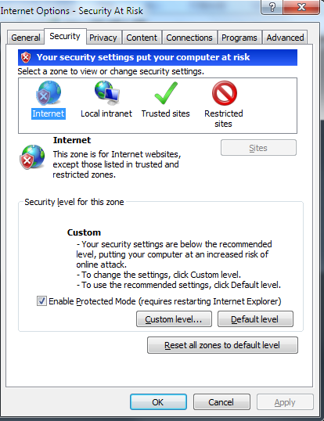

Login interface
After installing the control, the desktop will generate the application icon，Double-click to run, and the following login interface will appear.Enter the device password (default is 888888) and click the "login" button to log in the device.
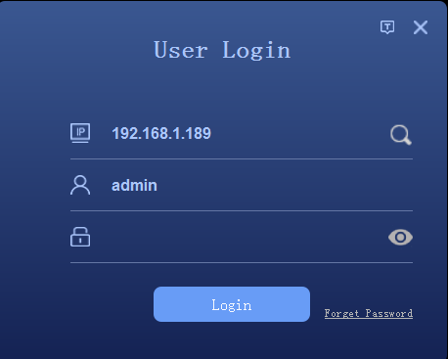
Or clickto enter the device search interface, click the "search" button to search the device and select the device to log in.
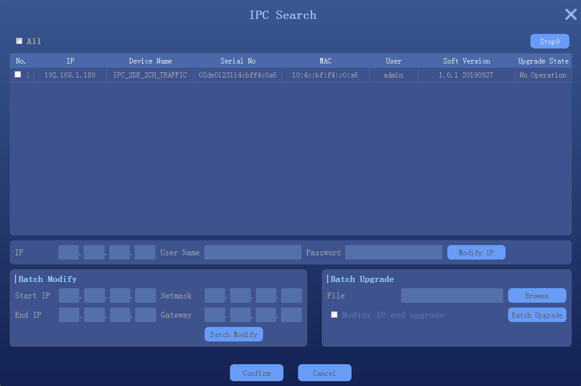

Preview interface
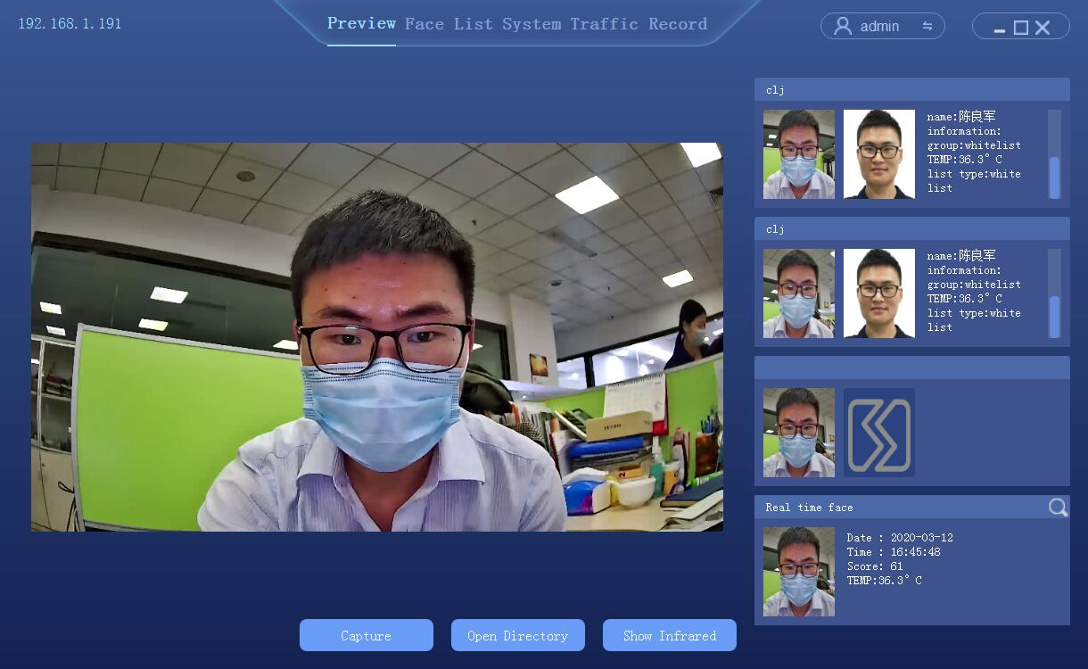
1
2
3

- Live preview window
- Comparison results show: similarity, name, description, group, temperature, list type
- Real-time snapshot results show: snapshot time, image threshold, body temperature

List management
List management, face database management, single face registration, batch face registration, real-time face image import.

Face picture requirements

To ensure the accuracy of the recognition, use a recent and new photo. Only one face in the picture has a width of 260 pixels or more.
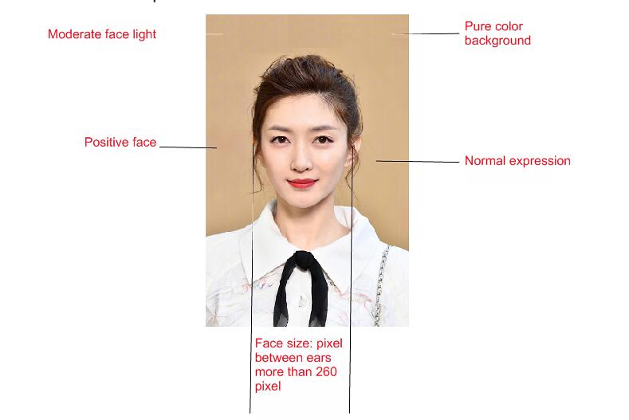

Note: face image must not be more than 1M, so as to avoid failure when importing face library

Single face import
Select "list management" to enter the list management interface, as follows
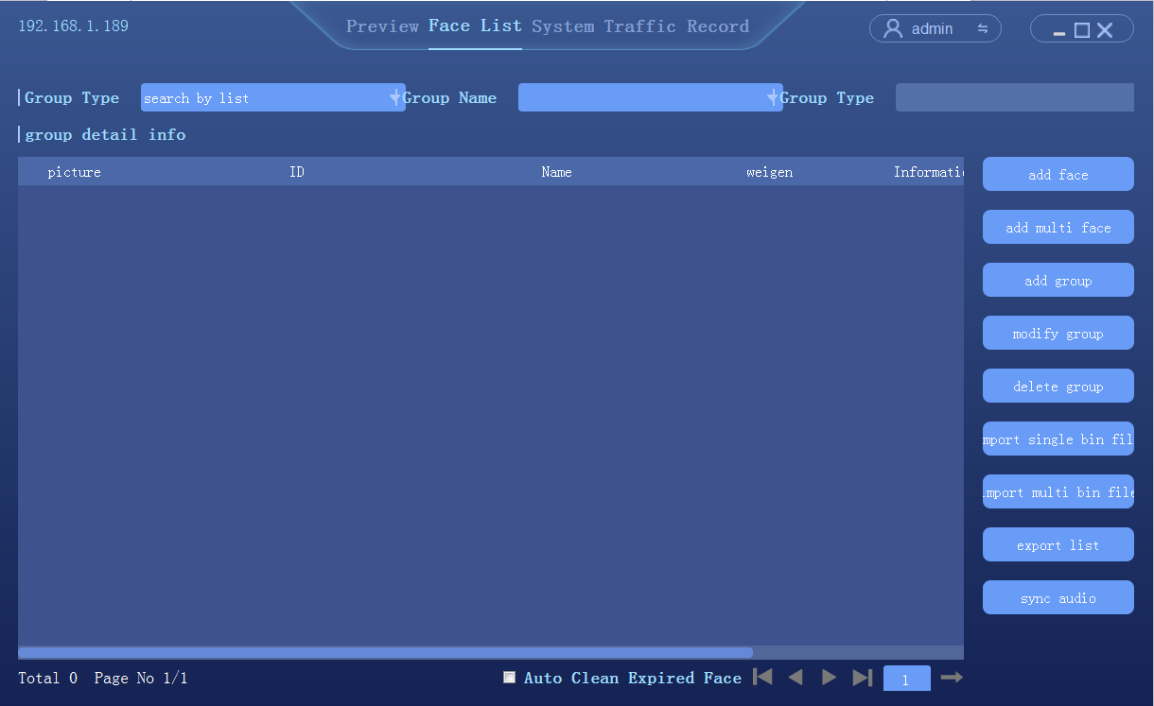
Steps：
- Add group: set the group name and group type (whitelist, blacklist or visitor)
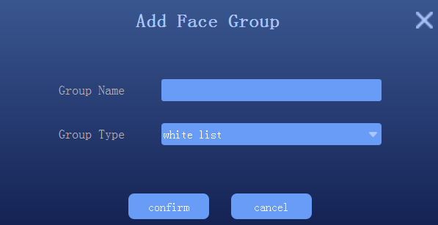
Description：
Visitor type grouping, setup the time period, and check，hen the face data will be automatically deleted from the face library after reach the expiration time.

- Select add new face
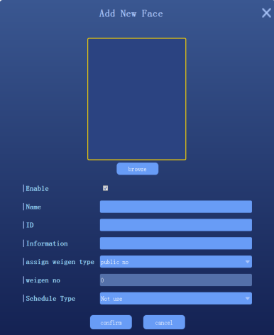

- Click [browse] to check the location of face photo and select
- Fill in name, ID, Information.,etc
- Click “confirm” to end

Batch add
Select "list management" to enter the list management interface, as follows.
Steps：
- Add group: set the name and group type (whitelist, blacklist or visitors)
- Select "add multiple faces"
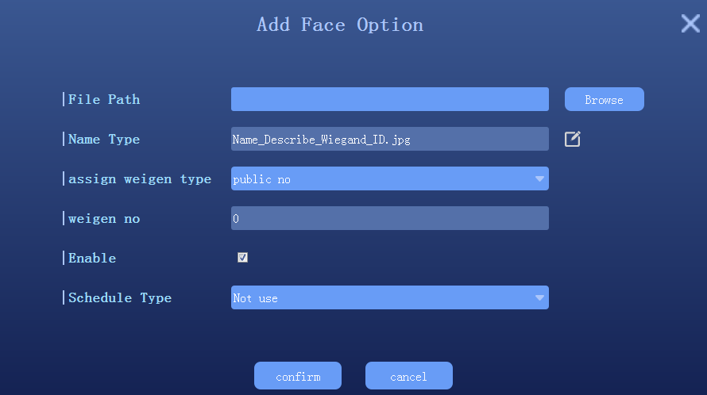
- Clickto setup face image import format; Note: the face photo naming format should be corresponding to avoid import failure
- Click [browse] and select the folder corresponding to face library
- Click confirm and wait for the import to complete the import

Real-time face image import
In Preview interface, when a person passes by the device, the device will keep to capture the human face. Click the iconon the right side of the human face to view the picture captured in real time, as shown below:
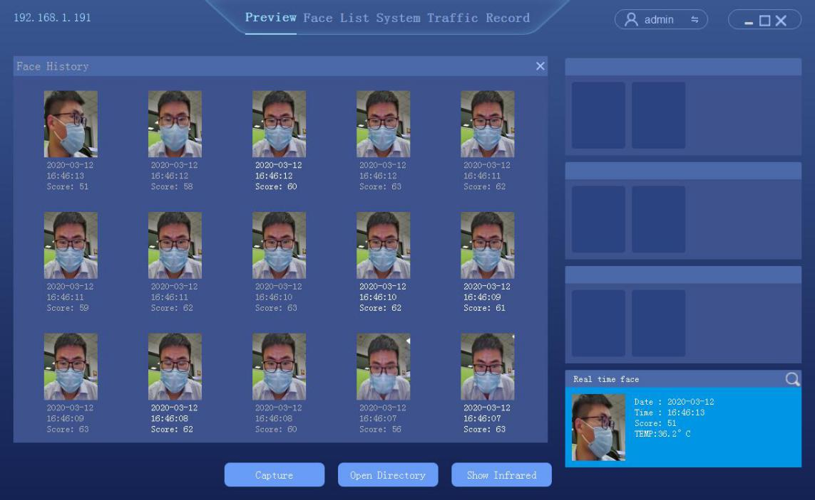
In the face history, select the face image as the template to import into the device
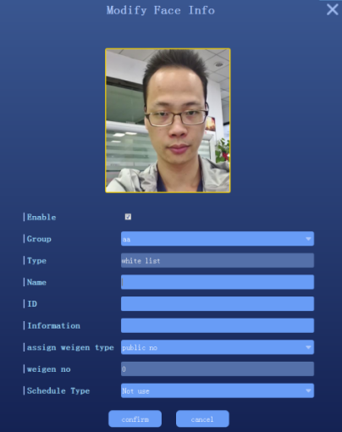
Note: For this import mode, groups need to be setup in advance in the list management

Binary format face library import
The device supports one or more binary format grouping face library import, select "single bin file" or "multiple bin file" respectively, as follows
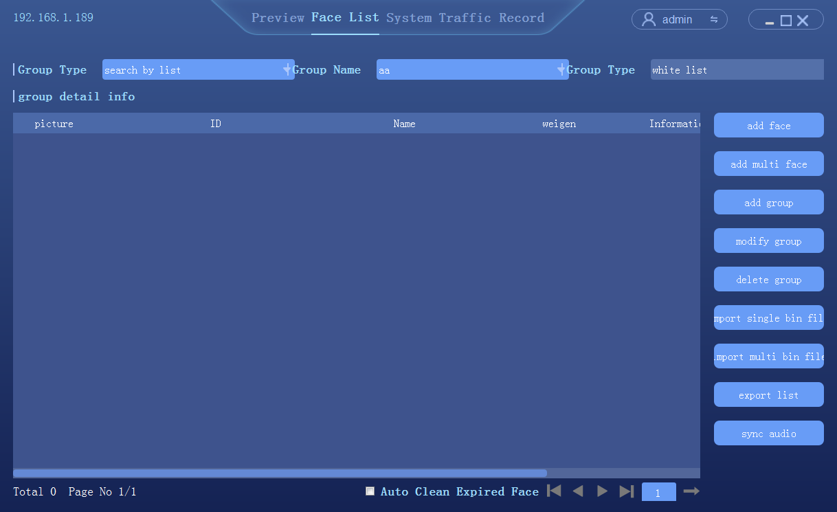

Exported face library
In the list management screen, see below

- Click export face list；
- Setup the save path of face library export
- According to the group name, automatically export all groups in the face library, save the format as binary (.bin) file
- When finished, click "ok"

Peripheral control

Basic setup
Click [peripheral] → [system] to enter the system setting interface
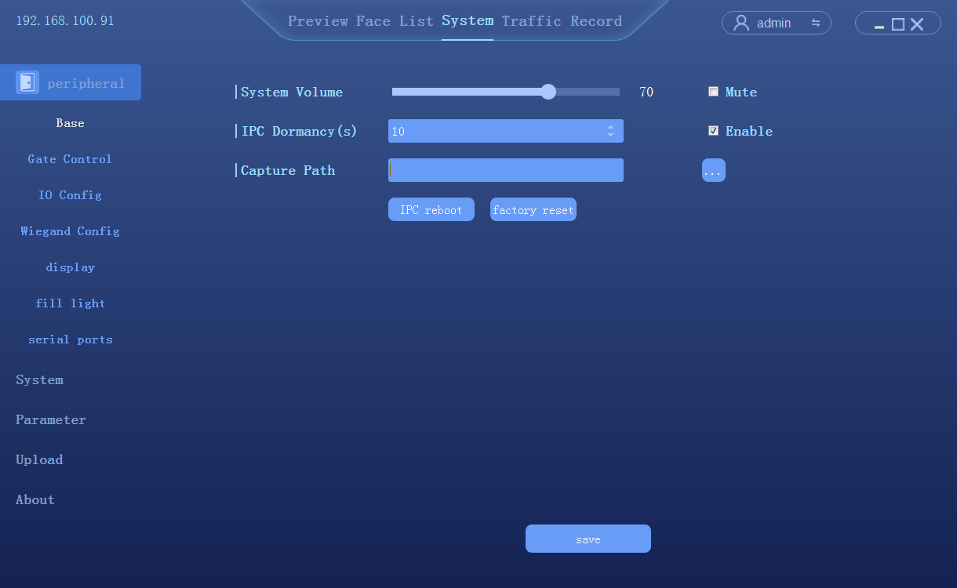

Gate control
Click [peripheral] → [Open Mode] to enter the Open Mode control interface
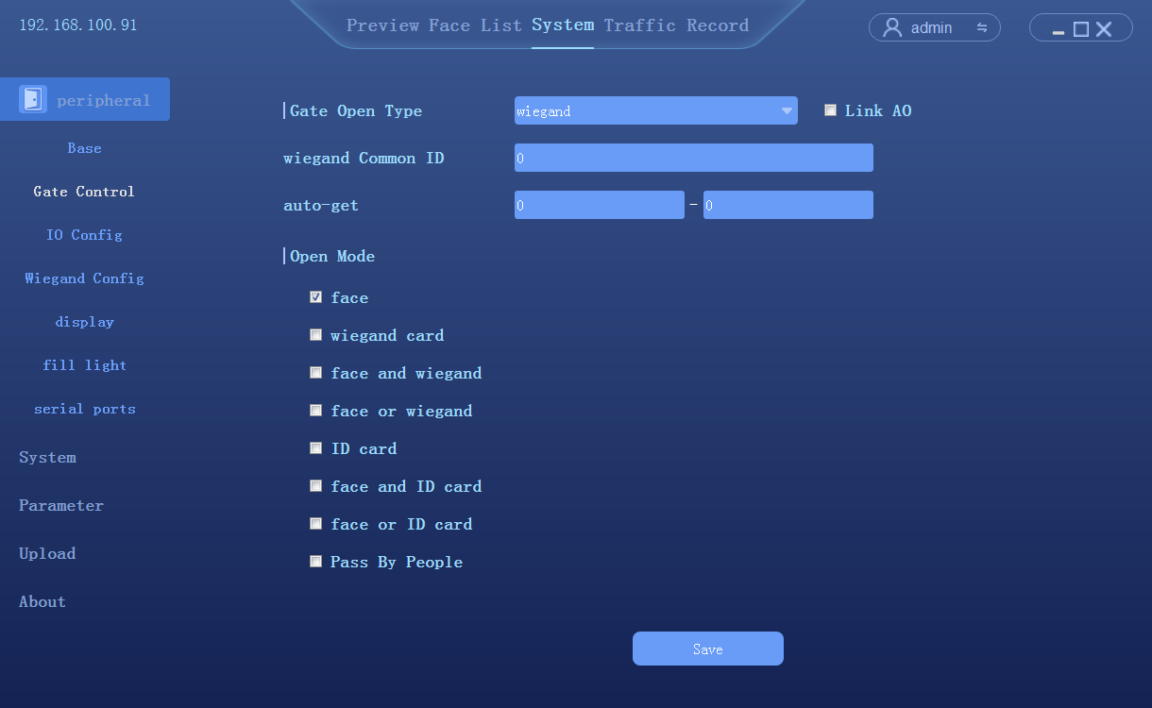
- Gate open type: can select relay or wiegand two ways
- Relay. : relay channel 0 (out0) or relay output channel 1 (out1)
- Delay time: hold time of opening state
- Open mode：
- Face: The capture face matched the face in database to open the gate
- Unification of face and ID card: The capture face matched the face in ID card to open the gate
- Pass the gate: Once someone to open the gate

GPIO control
Click [peripheral] → [GPIO] to enter the GPIO control interface
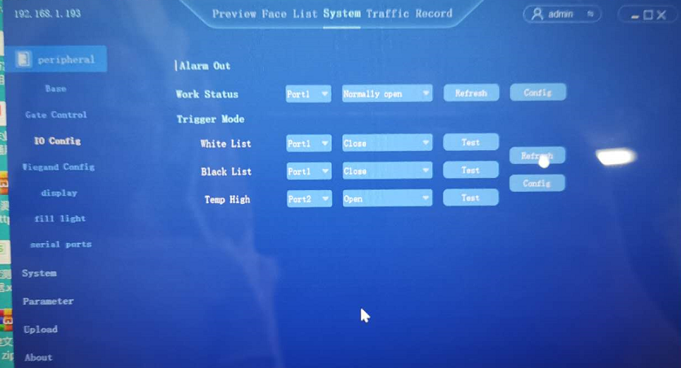

Wiegand Config
Click [peripheral] → [wiegand configuration] to enter the wiegand configuration interface。
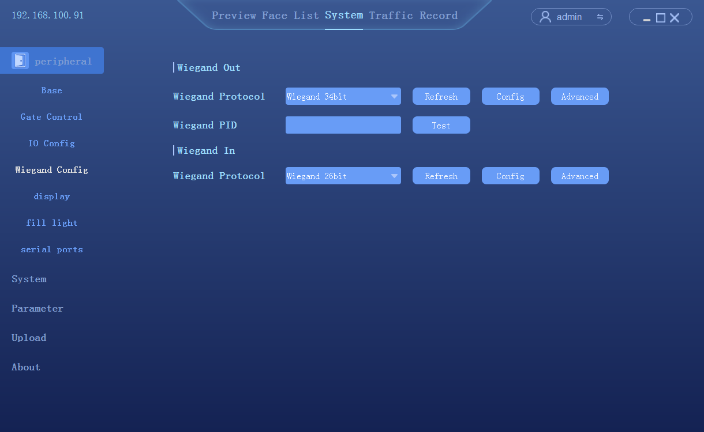
- Wiegand protocol (output) : wiegand 26 bit/wiegand 36 bit/wiegand 66 bit optional
- Wiegand number: test to see if wiegand works
- Wiegand protocol (input) : wiegand 26 bit/wiegand 36 bit/wiegand 66 bit optional

Display Settings
Click [peripheral control] → [display Settings] to enter the display Settings interface
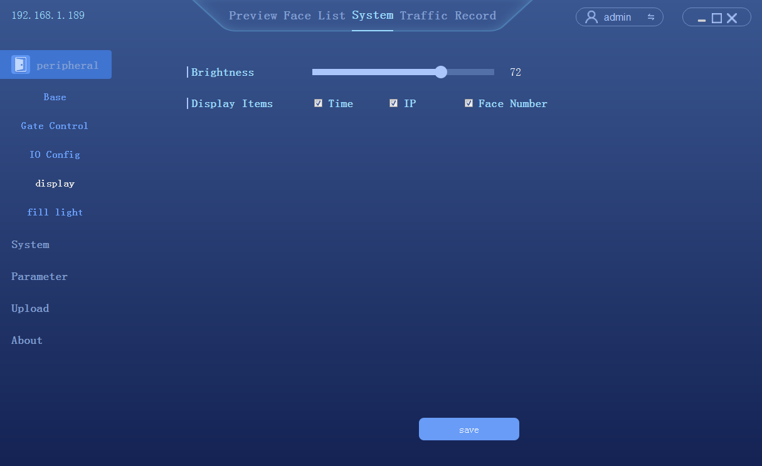

Fill Light
Click [peripheral control] → [fill light] to enter the fill light interface
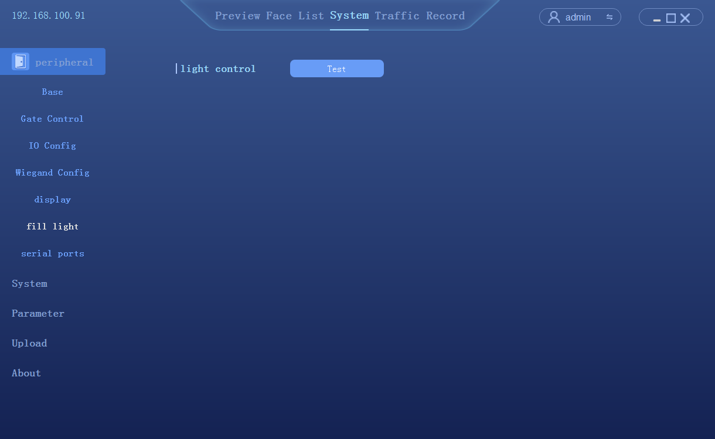
- Test to see if fill light works

4.5.7 Serial port
Click [peripheral control] → [serial port] to enter the serial interface
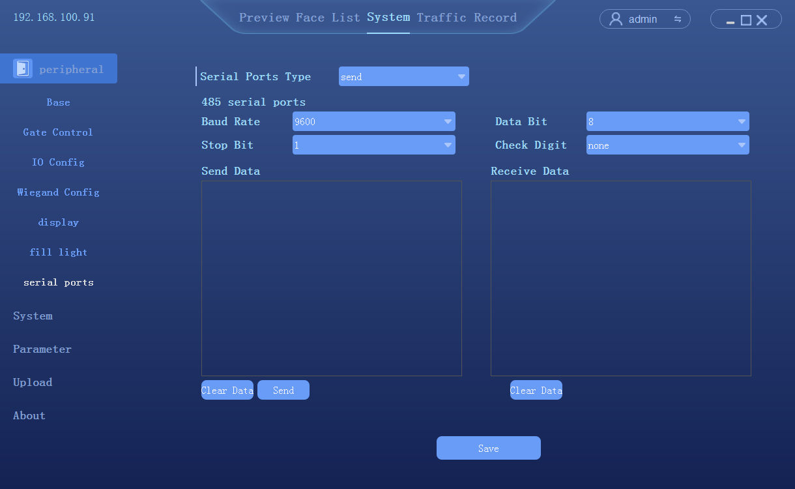
- Serial port type: send/receive

The system configuration

Setup the time
Click [System] → [Time] to enter the time setting interface
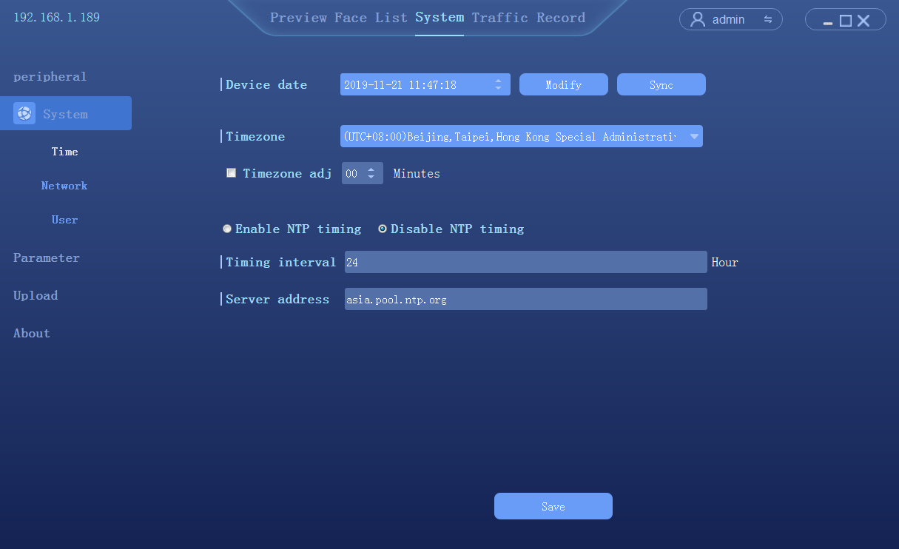
- Device date: To configure the device time. Mode: Manual modify and PC synchronization
- NTP: The device synchronize the time with the network NTP server

Network Settings
Click [System] → [Network] to enter the network settings interface
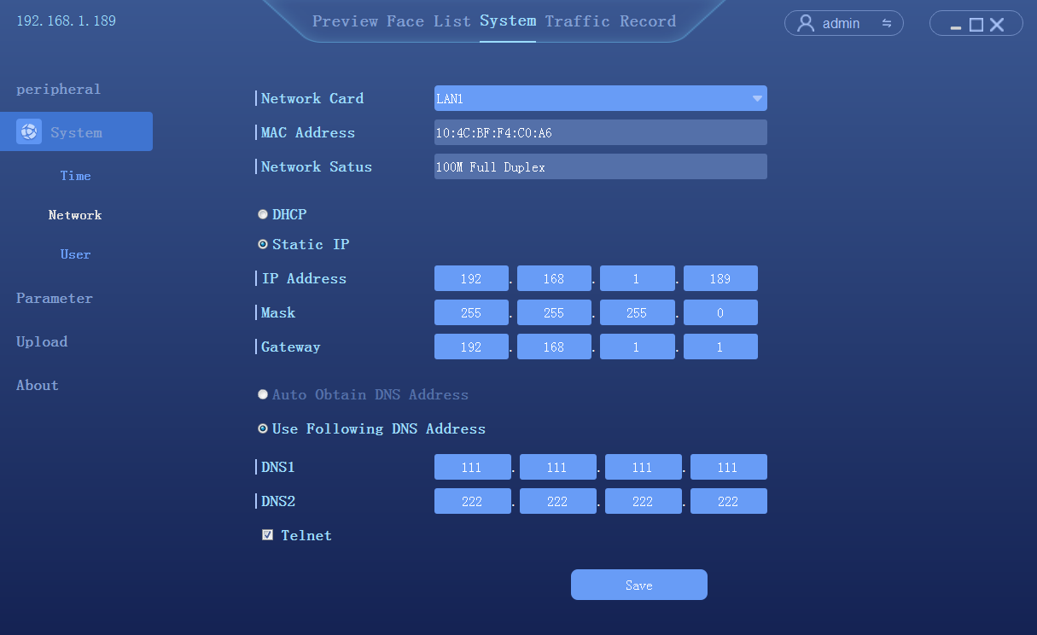

P2P
Click [System] →【P2P】，to enter the P2P settings interface
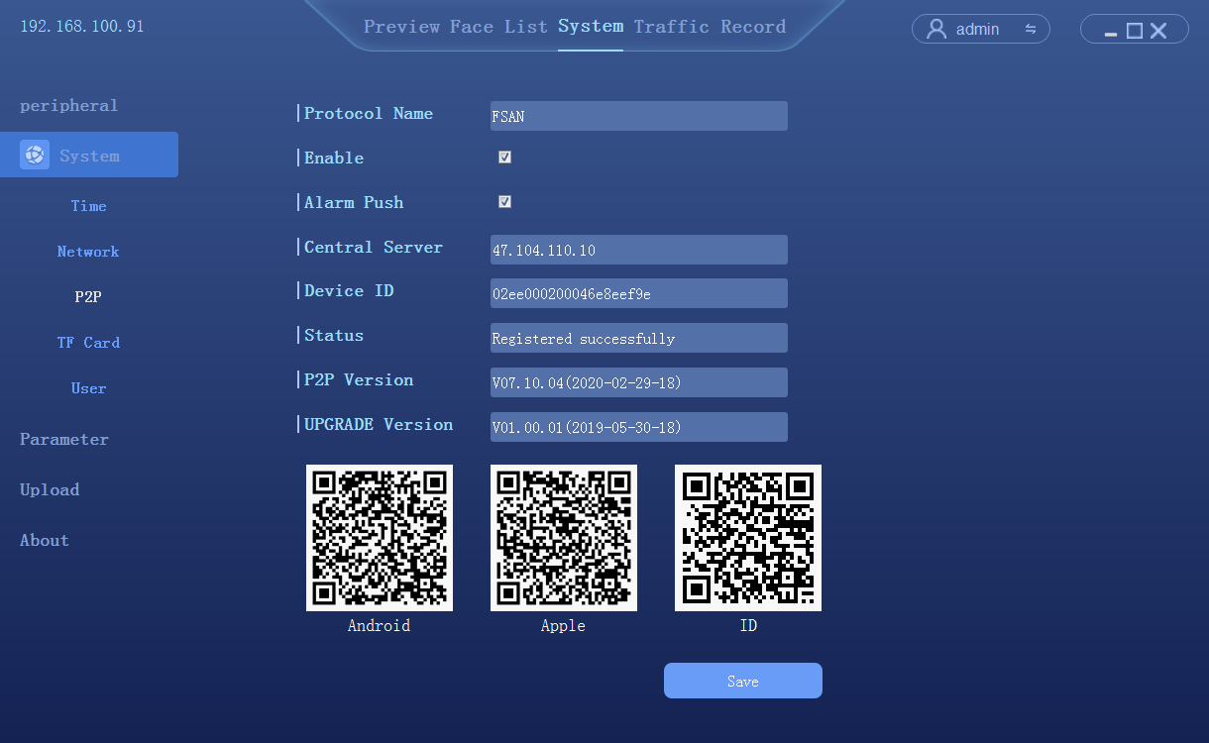

- [download mobile app] → [scan ID add device] enter the Faceeye interface. Note: the device IP must be able to go on the outer network

TF Card
Click [System] →【TF Card】，to enter the TF card settings interface
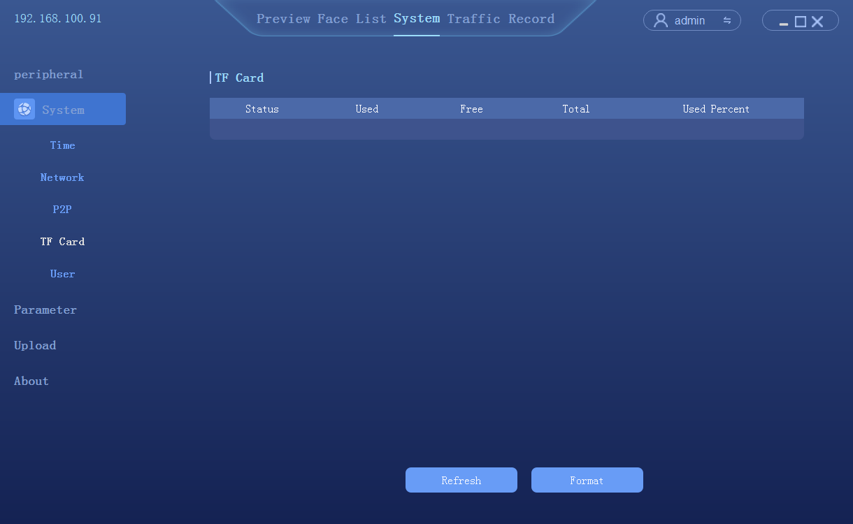
- Check the status of TF card in real time. Actual functionality (under development)

User management
Click [System] → [User] to enter the user management interface

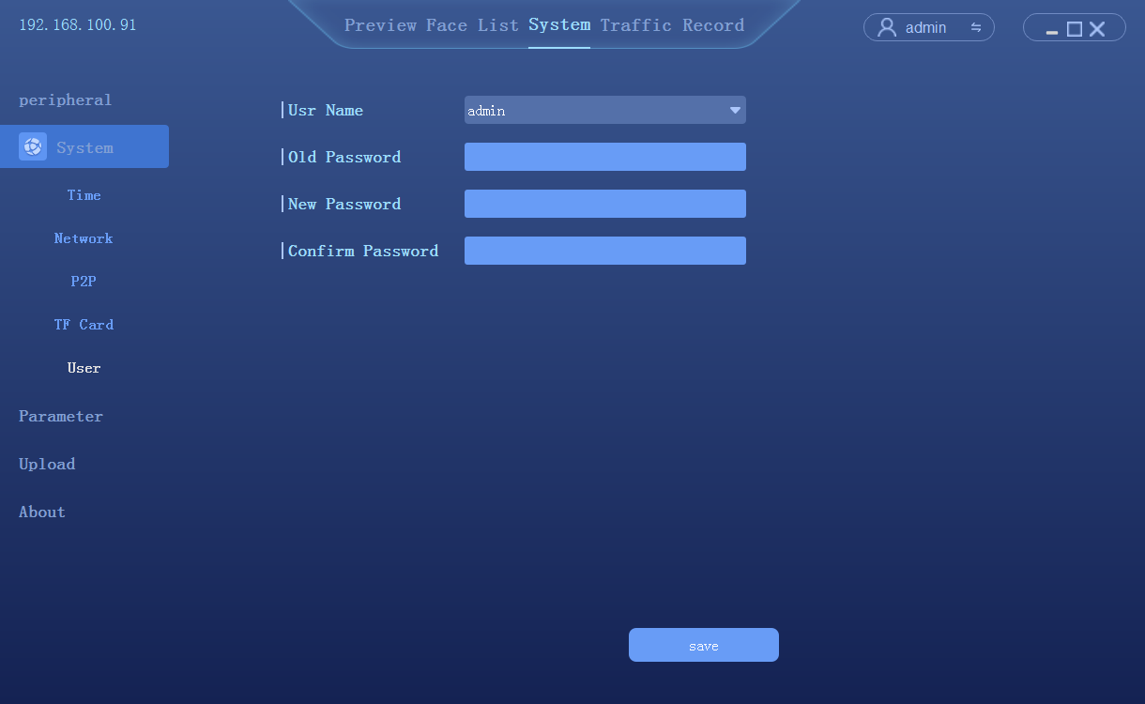

Parameter Settings

Face detection
Click [System] → [Parameter] → [face detect] to enter the setting interface
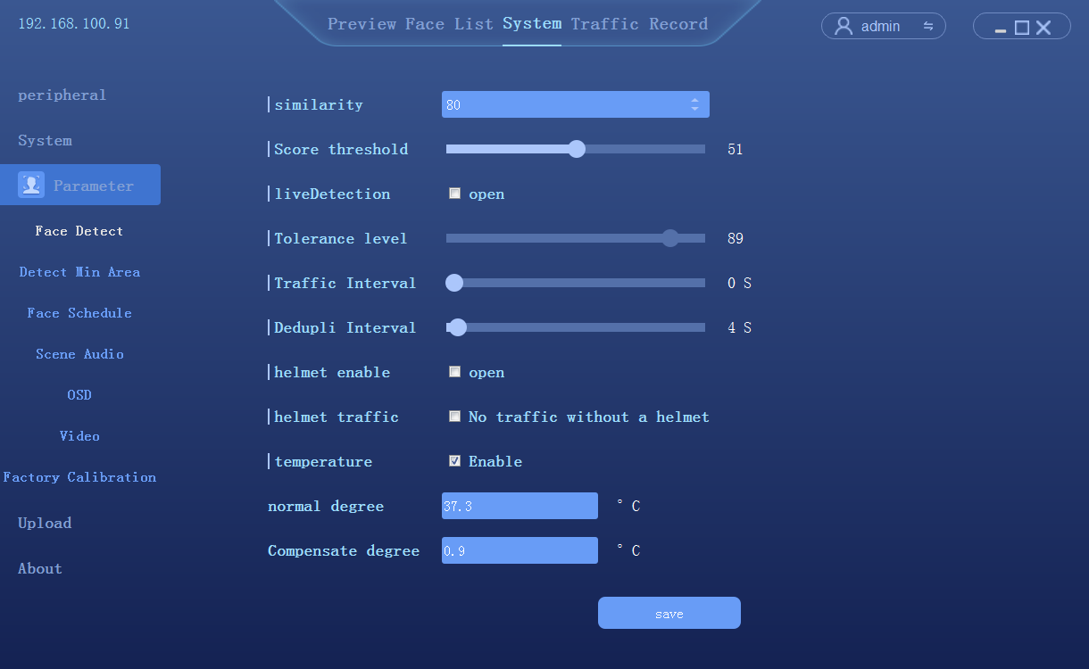
- Enable the temperature detection
- Normal temperature degree: To setup a default temperature here. The alarm out will be triggered once the temperature detected is higher than the default value. The device support 2ch alarm output, please go to GPIO setup to open Temp High to trigger alarm output.
- Temperature correction: compensation according to the measured temperature

Detect target minimum size
Click [System] → [Parameter] →[Detect target minimum size] to enter the setting interface
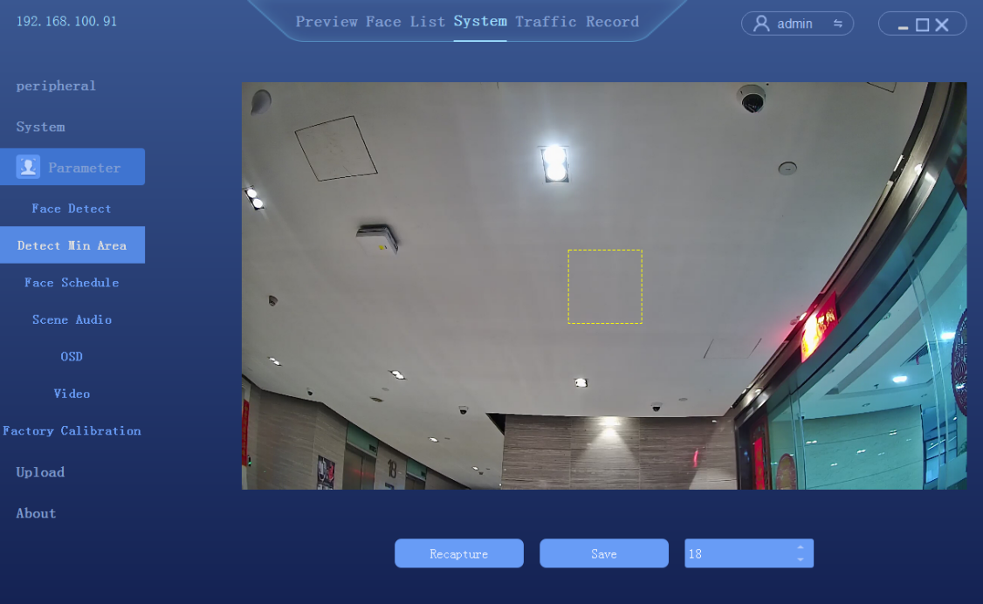
- Detection target size 1-82 is optional

Dispatching management
Click [System] → [Parameter] →[dispatching management]to enter the setting interface
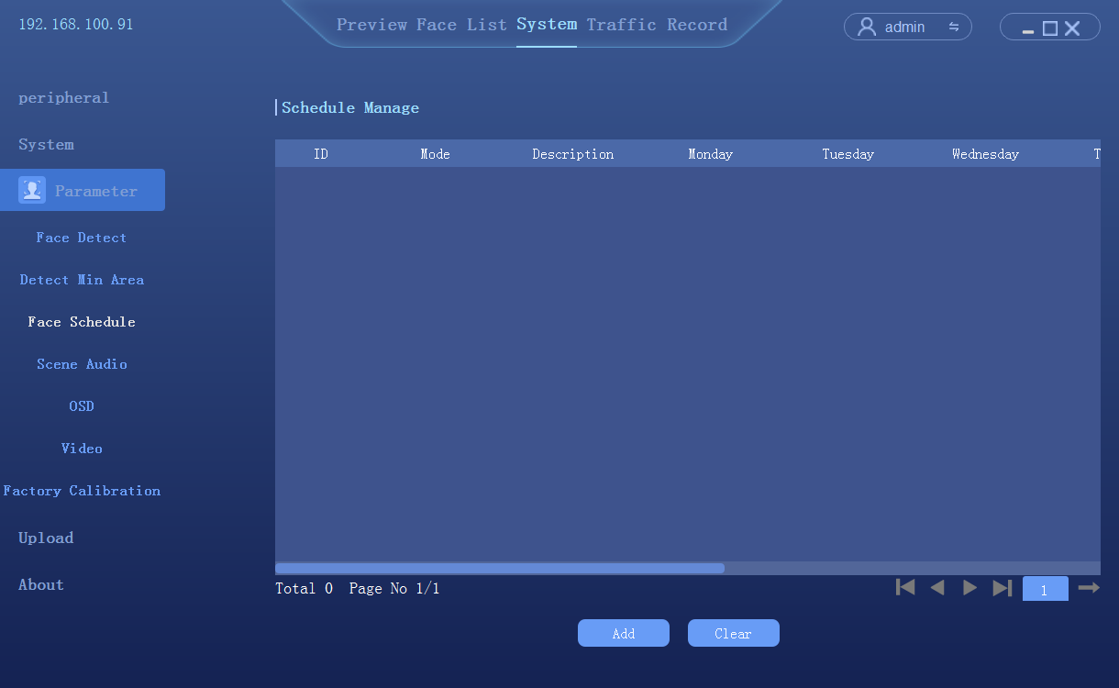
Click [add]to enter the interface of scheduling time setting, total of 6 time periods can be set
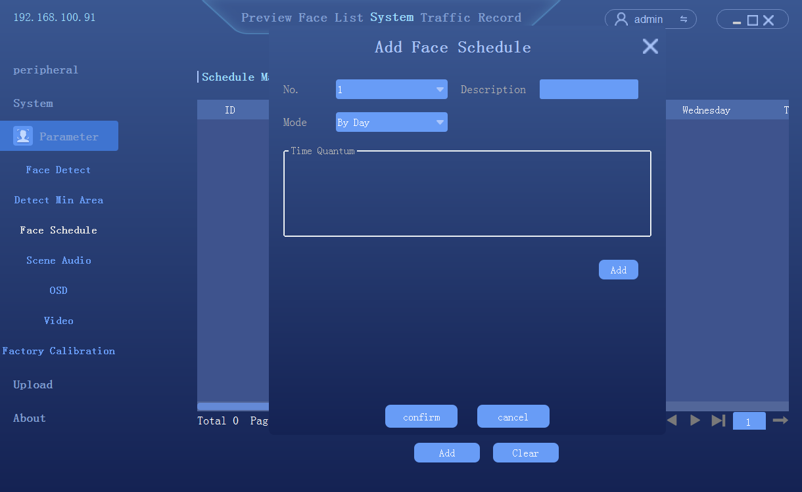

Scene Audio
Click System → Parameter → Scene Audio to enter the setting interface
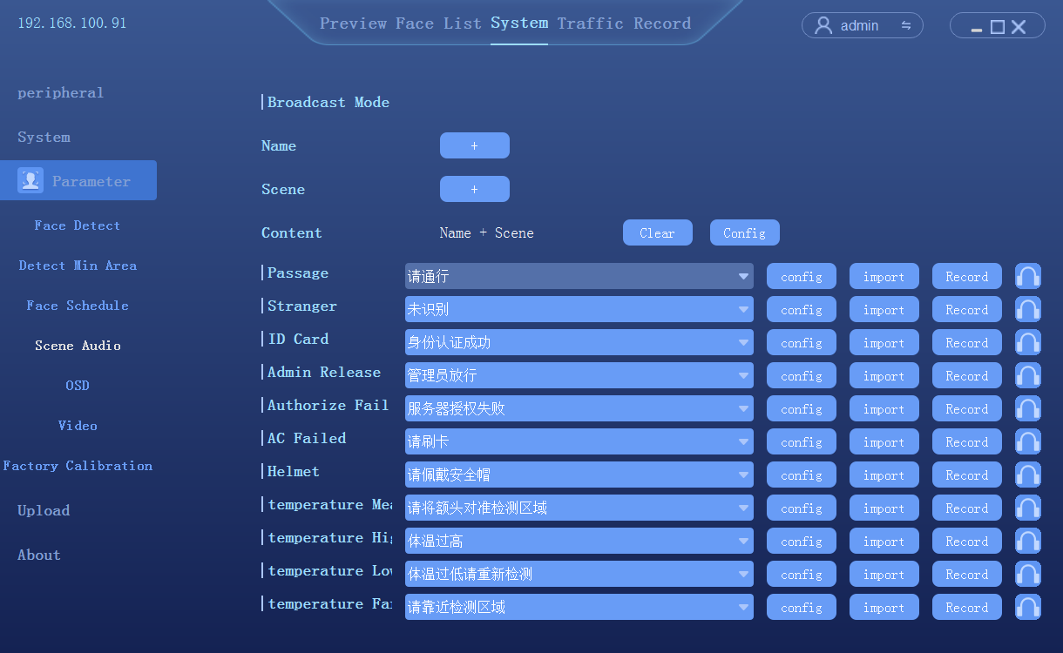
- Broadcast mode can be customized
- All voice prompts can be imported or recorded(The computer system must have Windows/TTS function)

OSD Setting
Click [System] → [Parameter] → [OSD] to enter the setting interface
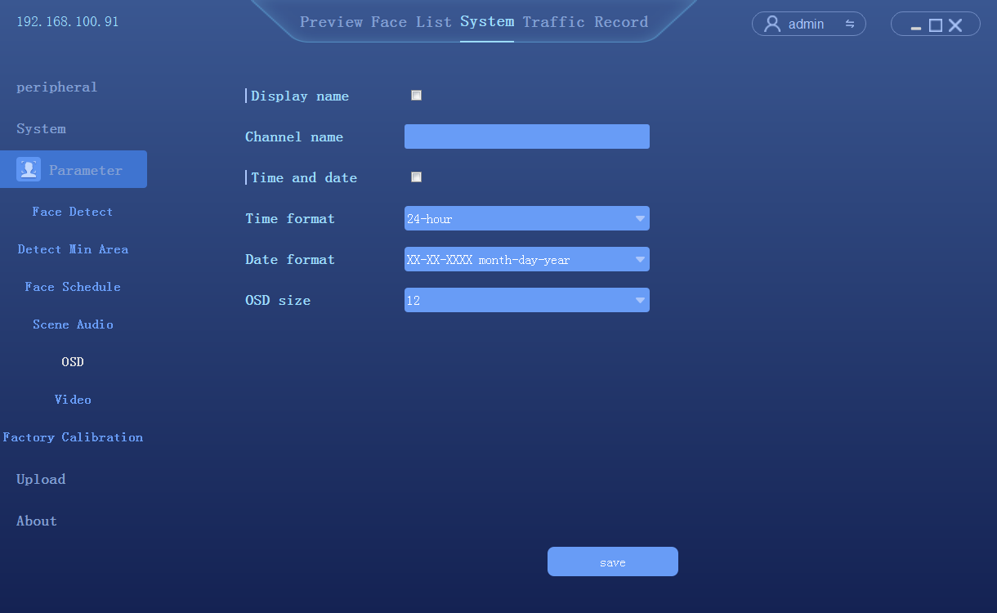

Video parameter setting
Click [System] → [Parameter] → [Video parameter setting] to enter the setting interface
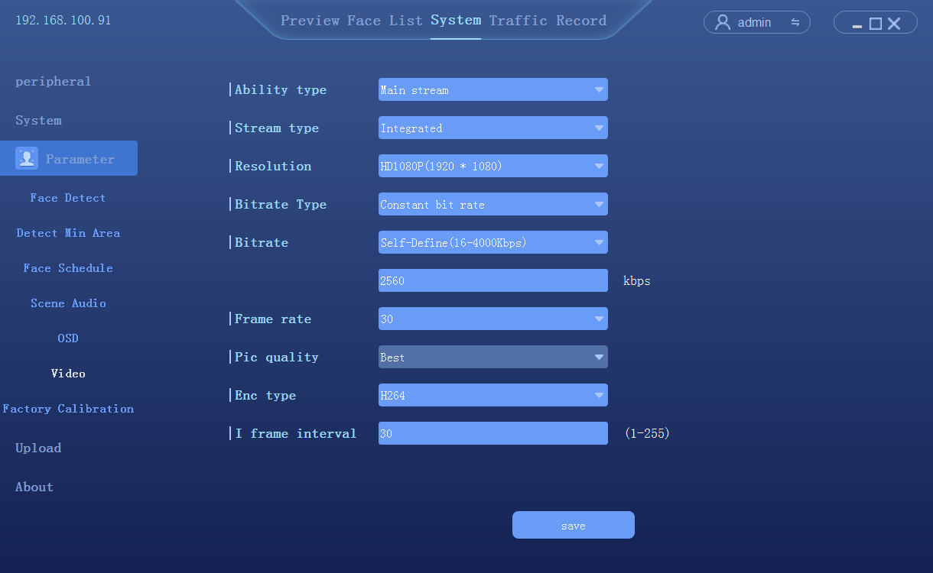

Factory calibration
Click [System] → [Parameter] → [Factory calibration] to enter the setting interface
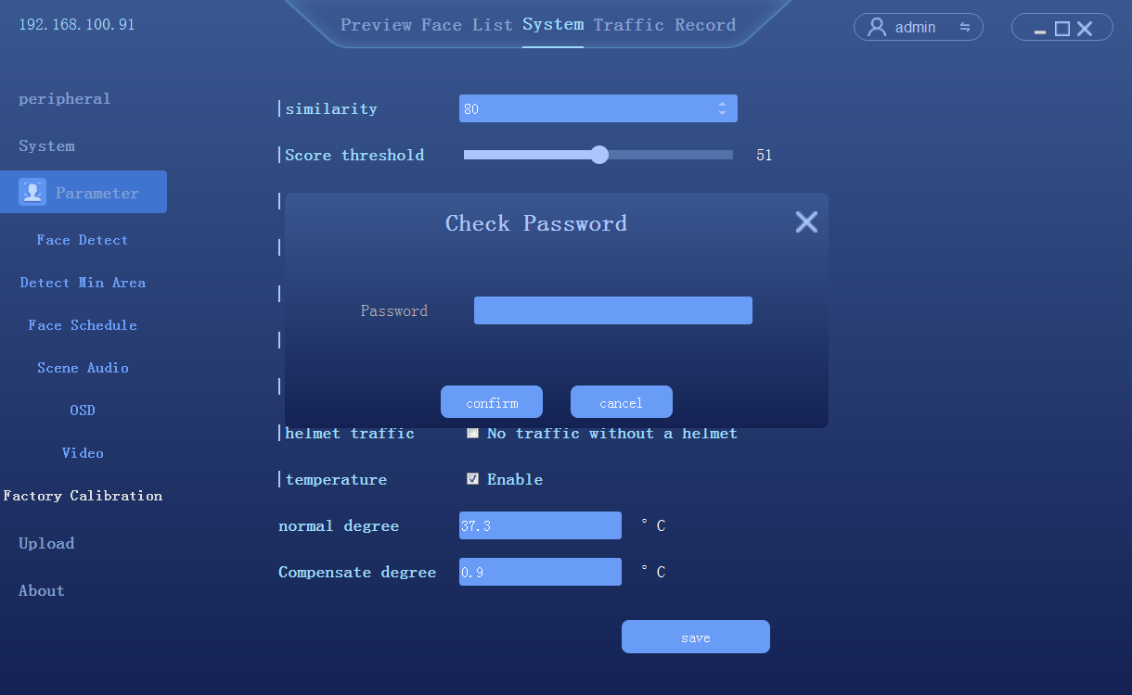
- Pre-factory calibration,closed to the public

Data upload
Click [System] → [Data upload] to enter the setting interface
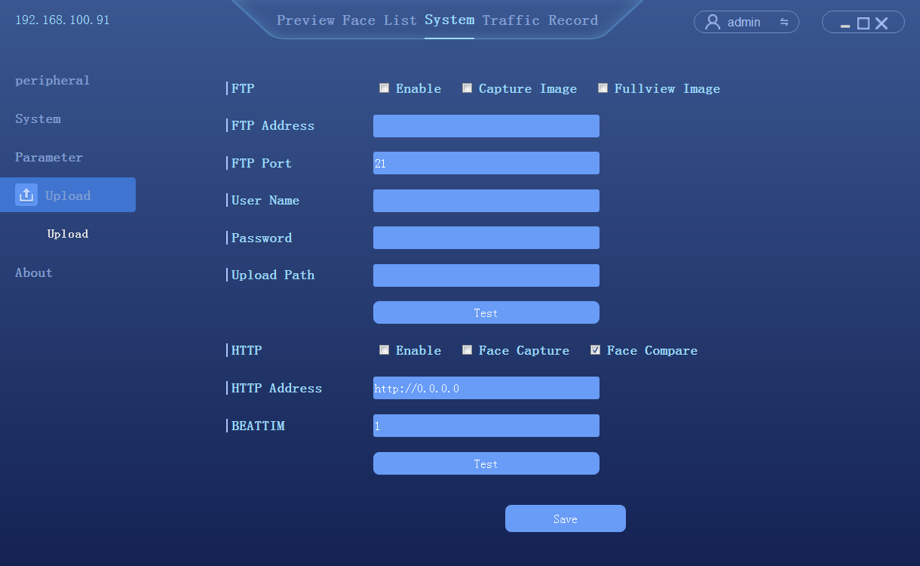
- Data upload: FTP/HTTP two ways, upload pictures can be selected to capture or compare pictures

About

About
Click [System] → [About] to enter theinterface
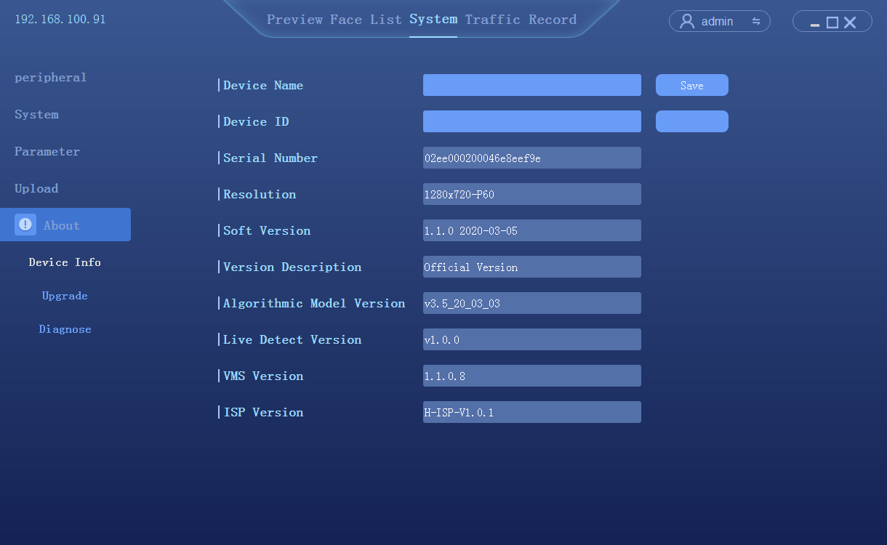

- Name：Self-setting
- Device serial number: display camera serial number
- Display resolution: the resolution of the camera screen
- Firmware version: displays the current firmware version of the camera
- Version description: a description of the current firmware version
- Face algorithm version: the version of the face recognition algorithm used by the camera
- Client version: the current client software version of the camera

Firmware upgrade
Click [System configuration] → [system information] to enter theinterface

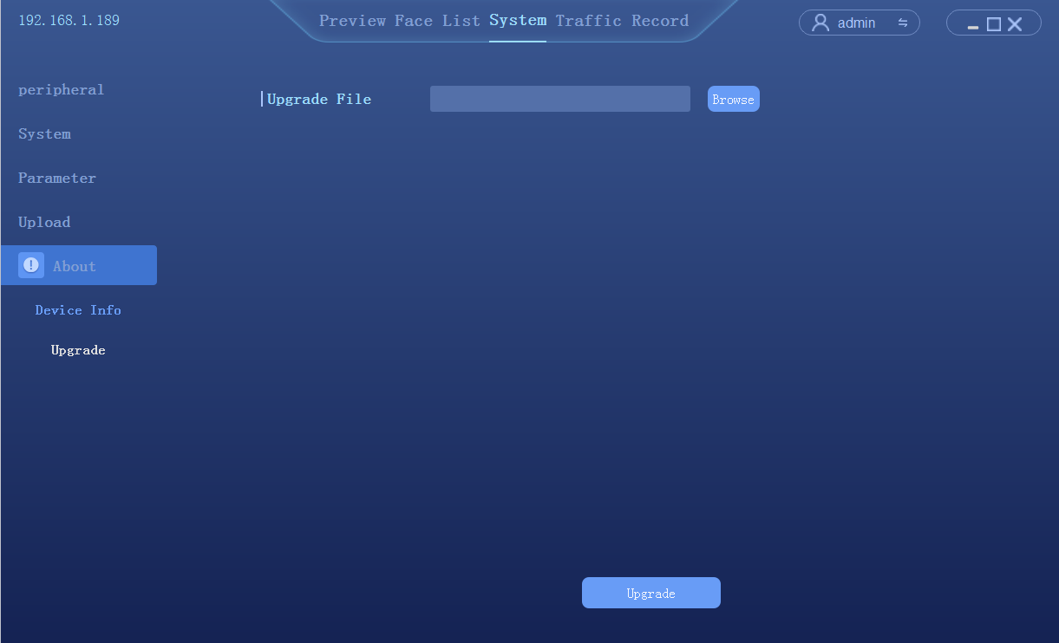

System Diagnostics
Click [System configuration] → [system information]→ [System Diagnostics] to enter theinterface

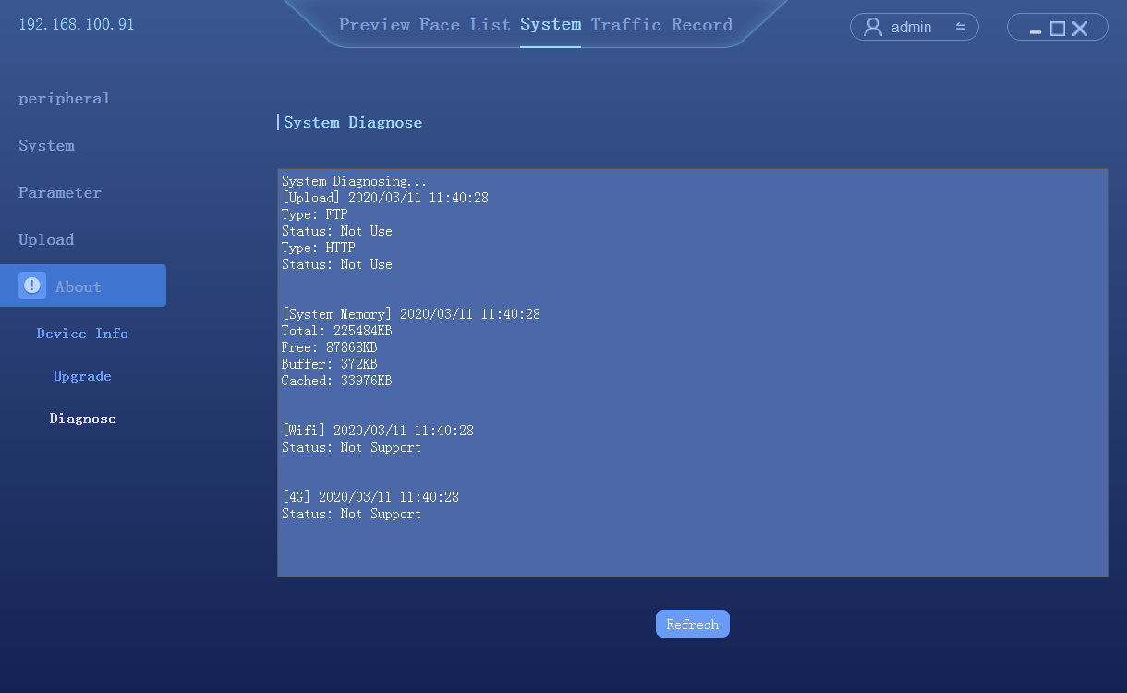

Access records
Query the history of the catch, export the record as needed, export the record including Excel file and the catch photo
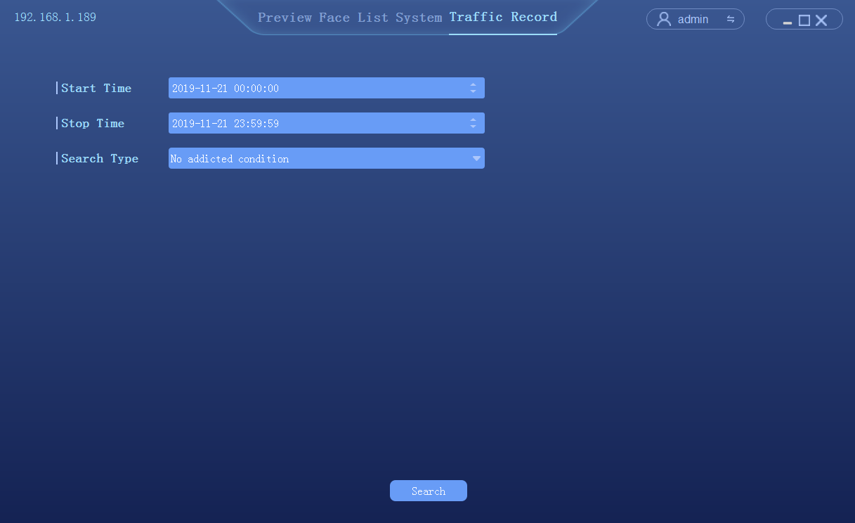
- Set query time period: start time and end time
- Select search type：
- No additional information query: query all traffic records in the corresponding time period
- According to the type of access: list management, pass, id card, authorized passage, stranger access
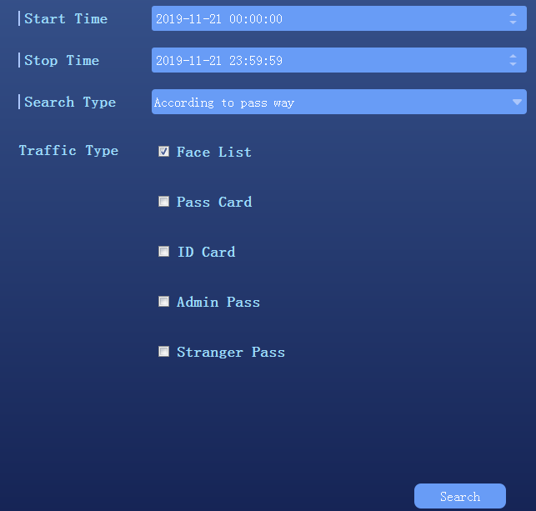
- According to the list query: white list, blacklist, visitor list
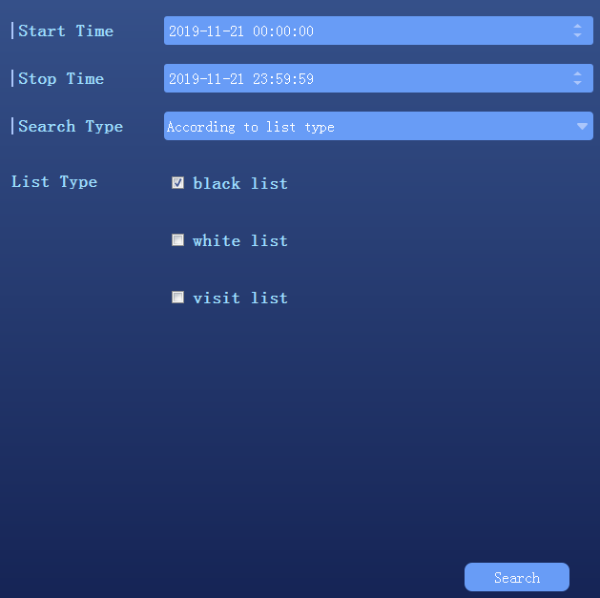
- According to other information query: input name or id number query
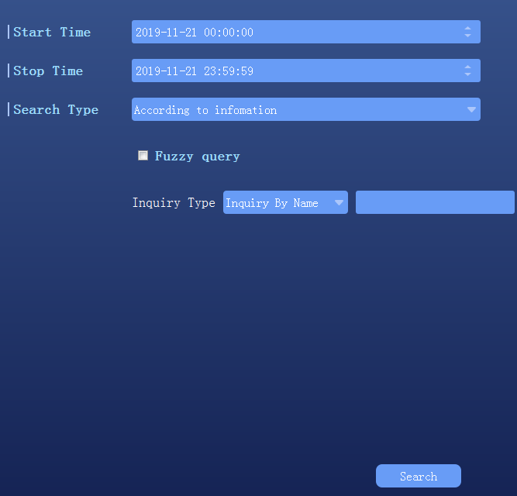
- According to the slice query: to compare the search chart
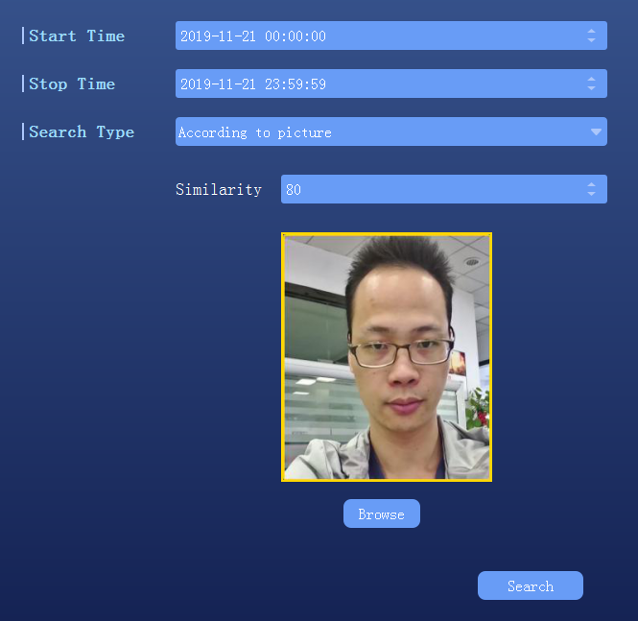

- Retrieval, the query result is shown as follows：
