please follow steps below to collect dump disk logs for further analysis

- Please set NVR admin password as 123456

2.copy the asdbg file to an empty FAT32 format USB stick (the USB stick should have the asdbg file only ,also pls put the file on root path of the USB stick,not under any folder )

3.plug the USB stick to USB2.0 port (the white one)of the recorder

4.reboot the recorder and you should see a warning pops up like below(if there's no
this warning after reboot ,please try other USB ports or try another USB stick
with FAT32format)---IMPORTANT !! ， because if this warning didn’t show , the USB stick won’t record anything useful after you start step 5 below .
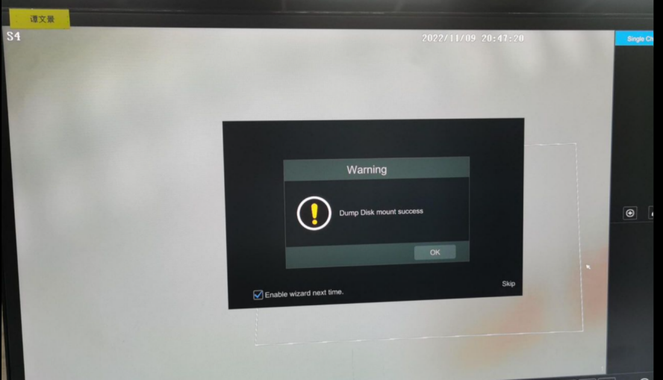

5.keep the USB stick there and repeat the issue for at least 2-3 times,then wait another 5 mins and send all the files in it to me , thank you !

