Manual for Update to 1.3.X
There are 3 conditions for updating to 1.3.X:

Condition 1.
When the version is 1.0.X or under, you are not able to update to 1.3.X

Condition 2.
When the version is 1.1.X and 1.2.X, follow the steps below to update to 1.3.X.
(Note: If the device with 1.0.X then can’t update to 1.3.3 at present).:

- We need use USB disk to update please follow the ways to update step by step.
- Copy the four files appfs_special_XXXXX、firmwareXXXXX、XXX_UI1A_XXXX.fls、ubXXXXX to the root directory of your USB Disk（Fat32 format will be better） then power on your device and device will update itself.
Picture 1

All The follow steps will run automatically, please do not power off while updating.

- All the upgrade processes will appear on the screen, Such as Picture2 it will take about 5 minutes. After update success then it will show the picture3 &4.
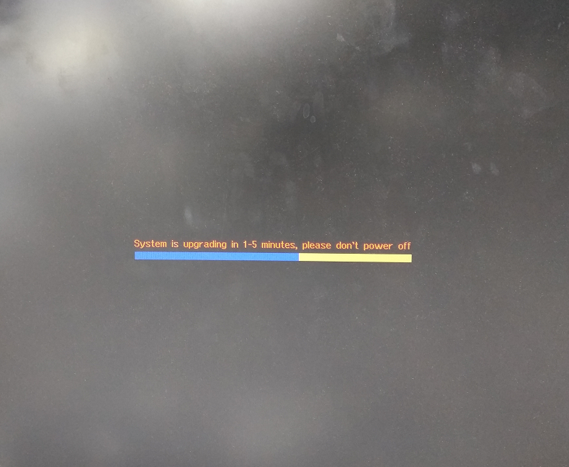
Picture 2
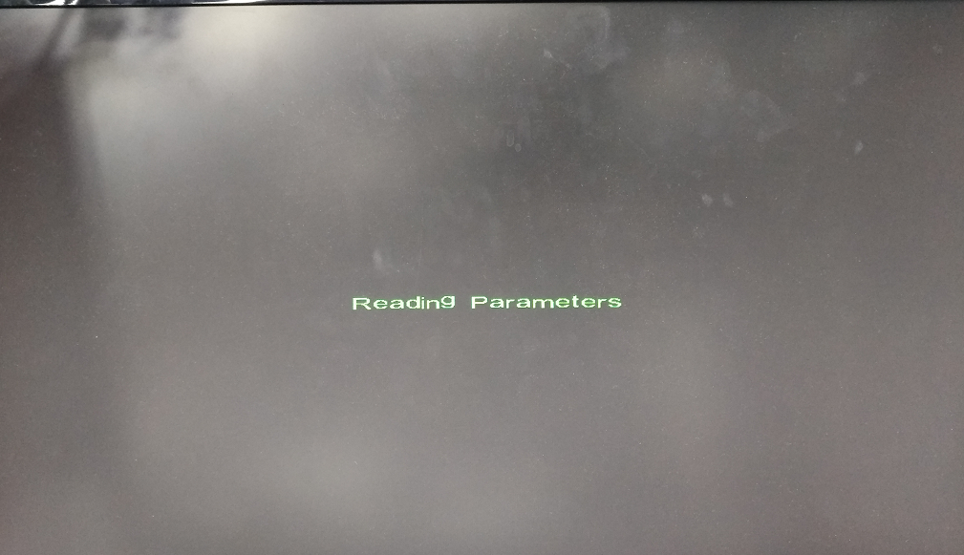
Picture 3
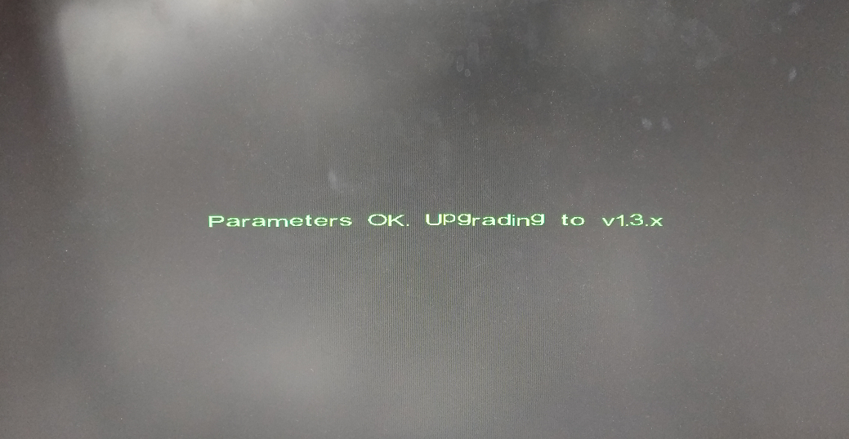
Picture 4
- After that Device will automatically update to 1.3.3 ,Device will show picture5 and it take about 1-5 minutes, After that device will show the logo picture about 30 seconds，Then show the picture 6 ,After all steps finished then it will update successfully.
Picture 5
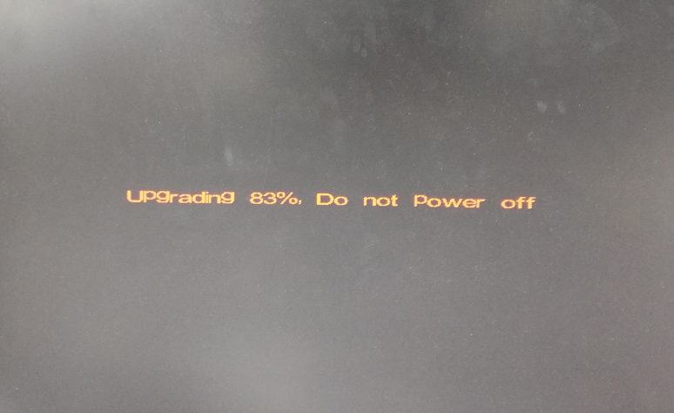
Picture 6
PS：If the disk is connected to the device for a period of time（more than 18
minutes） but the screen always black, you can try to plug out and plug in the video cable, if still black screen then you can plug out the U disk and try changing the usb port to then reboot device to update again.
Plug the USB drive in the USB Port at front panel is suggested for increasing the efficiency.

Condition 3.
When the version is 1.3.0 or above, follow steps below to update to version 1.3.3
- We need use USB disk to update please follow the ways to update step by step.
- Only copy the four files firmwareXXXXX、XXX_UI1A_XXXX.fls to the root directory of your USB Disk（Fat32 format will be better） then power on your device and device will update itself.
Picture 1

All The follow steps will run automatically, please do not power off while updating.
- Then same steps as Condition 2.

Reference:
Please find below document to download your lastest update file

